Flutter provides three types of animations:
- Implicit animations: These animations are built into the widgets and are triggered by changing the widget's properties.
- Explicit animations: These animations are controlled by an AnimationController and are used to animate properties that are not built into the widgets.
- Custom animations: These animations are created using the Animation class and are used to create complex animations that are not possible with the built-in animations.
The below is a rough classification of Flutter animations: 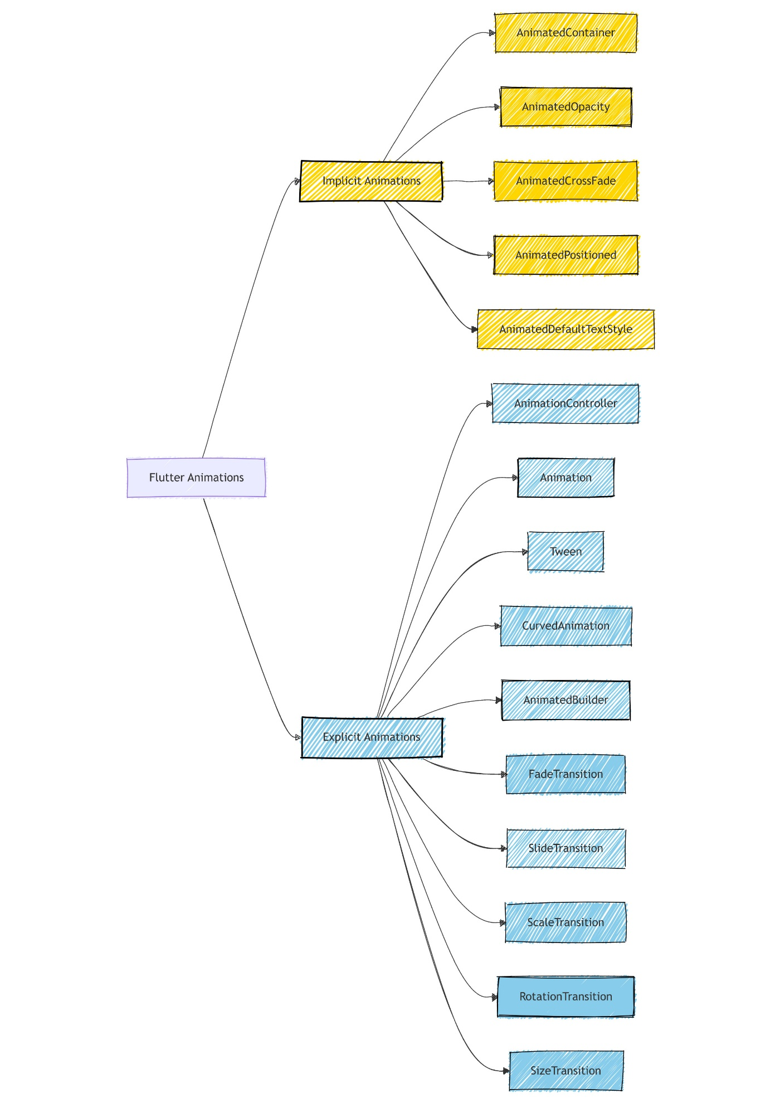

Choosing the Right Animation
- Implicit: Best for simple transitions where you want to animate from one state to another without manual control.
- Explicit: Suitable for complex animations that require precise control, synchronization, or custom behavior.
- AnimatedContainer.
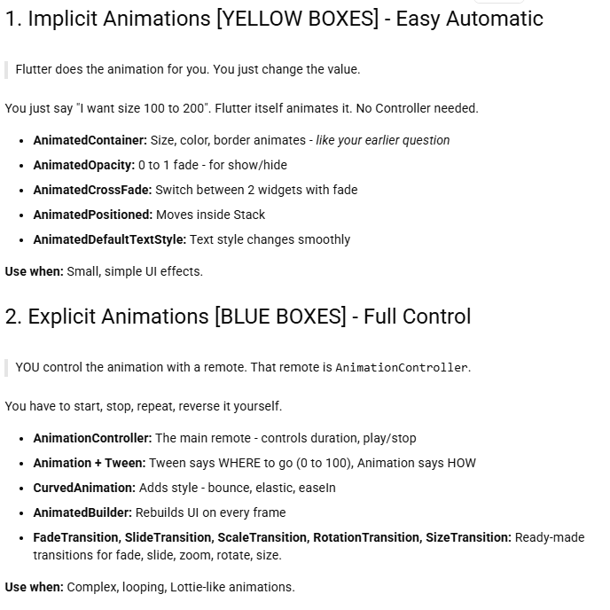
Unlike a normal Container, AnimatedContainer automatically animates changes in its properties.
can animate: width, height, color, padding, margin, decoration, alignment, transform
- StatefulWidget → allows the UI to change.
- Boolean variable → stores small/big state.
- setState() → updates the UI.
- GestureDetector → detects the tap.
- AnimatedContainer → creates the animation.
- Duration → controls animation speed.
- Ternary operator ? : → selects different values based on isBig.
TASK8A
To add animations to UI elements using Flutter's animation framework.
import 'package:flutter/material.dart';
void main() => runApp(const MainApp());
class MainApp extends StatefulWidget {
const MainApp({super.key});
@override
State<MainApp> createState() => _MainAppState();
}
class _MainAppState extends State<MainApp> {
bool _isBig = false;
@override
Widget build(BuildContext context) {
return MaterialApp(
debugShowCheckedModeBanner: false,
home: Scaffold(
appBar: AppBar(
title: const Text('Beginner Animation'),
),
body: Center(
child: Column(
mainAxisAlignment: MainAxisAlignment.center,
children: [
const Text(
'Tap the box to animate',
),
GestureDetector(
onTap: () {
setState(() {
_isBig = !_isBig;
});
},
child: AnimatedContainer(
decoration: BoxDecoration(
borderRadius: BorderRadius.circular(8),
color: _isBig ? Colors.deepPurpleAccent : Colors.blueAccent,
),
duration: const Duration(seconds: 1),
curve: Curves.easeInOutBack,
width: _isBig ? 250 : 100,
height: _isBig ? 500 : 100,
alignment: Alignment.center,
child: const Text(
'Box',
style: TextStyle(
color: Colors.white, fontWeight: FontWeight.bold),
),
),
),
],
),
),
),
);
}
}
TUTORIAL-1:
TEXT ANIMATION:
import 'package:flutter/material.dart';

void main() {
runApp(const MainApp());
}

class MainApp extends StatelessWidget {
const MainApp({super.key});

@override
Widget build(BuildContext context) {
return const MaterialApp(
home: Scaffold(
body: Center(
child: AnimatedText(),
),
),
);
}
}

class AnimatedText extends StatefulWidget {
const AnimatedText({super.key});

@override
State<AnimatedText> createState() => _AnimatedTextState();
}

class _AnimatedTextState extends State<AnimatedText>
with SingleTickerProviderStateMixin {
late AnimationController _controller;
late Animation<double> _animation;

@override
void initState() {
super.initState();
_controller = AnimationController(
duration: const Duration(seconds: 2),
vsync: this,
)..repeat(reverse: true);
_animation = CurvedAnimation(
parent: _controller,
curve: Curves.easeInOut,
);
}

@override
void dispose() {
_controller.dispose();
super.dispose();
}

@override
Widget build(BuildContext context) {
return FadeTransition(
opacity: _animation,
child: const Text(
'I disappear and reappear!',
style: TextStyle(
fontSize: 24.0,
fontWeight: FontWeight.bold,
),
),
);
}
}

Tutorial-2
Try fading animation for Text widget.
Solution
import 'package:flutter/material.dart';
void main() {
runApp(const MainApp());
}
class MainApp extends StatefulWidget {
const MainApp({super.key});
@override
State<MainApp> createState() => _MainAppState();
}
class _MainAppState extends State<MainApp> {
bool isVisible = true;

@override
Widget build(BuildContext context) {
return MaterialApp(
debugShowCheckedModeBanner: false,
home: Scaffold(
appBar: AppBar(
title: const Text('Fade Animation'),
),
body: Center(
child: Column(
mainAxisAlignment: MainAxisAlignment.center,
children: [
AnimatedOpacity(
opacity: isVisible ? 1.0 : 0.0,
duration: const Duration(seconds: 1),
child: Container(
width: 200,
height: 200,
color: Colors.blue,
child: const Center(
child: Text(
'Hello Flutter!',
style: TextStyle(
color: Colors.white,
fontSize: 20,
),
),
),
),
),
const SizedBox(height: 30),
ElevatedButton(
onPressed: () {
setState(() {
isVisible = !isVisible;
});
},
child: const Text('Animate'),
),
],
),
),
),
);
}
}
Task 8b
Animations to UI elements using Flutter's animation framework.
Program - Experiment with different types of animations. (fade, slide, etc.)
import 'package:flutter/material.dart';
void main() {
runApp(const MyApp());
}
class MyApp extends StatelessWidget {
const MyApp({super.key});
@override
Widget build(BuildContext context) {
return const MaterialApp(
home: AnimationDemo(),
);
}
}
class AnimationDemo extends StatefulWidget {
const AnimationDemo({super.key});
@override
State<AnimationDemo> createState() => _AnimationDemoState();
}
class _AnimationDemoState extends State<AnimationDemo>
with TickerProviderStateMixin {
late AnimationController _scaleController;
late Animation<double> _scaleAnimation;
late AnimationController _fadeController;
late Animation<double> _fadeAnimation;
late AnimationController _slideController;
late Animation<Offset> _slideAnimation;
late AnimationController _rotateController;
late Animation<double> _rotateAnimation;
bool _visible = false;
bool _sliding = false;
bool _rotating = false;
bool _scaling = true;
@override
void initState() {
super.initState();
_fadeController = AnimationController(
vsync: this,
duration: const Duration(seconds: 1),
);
_fadeAnimation = Tween<double>(begin: 1, end: 0).animate(_fadeController);
_slideController = AnimationController(
vsync: this,
duration: const Duration(seconds: 1),
);
_slideAnimation = Tween<Offset>(
begin: const Offset(-1.0, 0.0),
end: const Offset(1.0, 0.0),
).animate(_slideController);
_rotateController = AnimationController(
vsync: this,
duration: const Duration(seconds: 2),
);
_rotateAnimation =
Tween<double>(begin: 0, end: 1).animate(_rotateController);
_scaleController = AnimationController(
vsync: this,
duration: const Duration(seconds: 2),
)..repeat(reverse: true);
_scaleAnimation = CurvedAnimation(
parent: _scaleController,
curve: Curves.easeInOut,
);
}
@override
void dispose() {
_scaleController.dispose();
_fadeController.dispose();
_slideController.dispose();
_rotateController.dispose();
super.dispose();
}
@override
Widget build(BuildContext context) {
return Scaffold(
appBar: AppBar(
title: const Text('Animation Demo'),
),
body: Center(
child: Column(
mainAxisAlignment: MainAxisAlignment.center,
children: [
FadeTransition(
opacity: _fadeAnimation,
child: SlideTransition(
position: _slideAnimation,
child: RotationTransition(
turns: _rotateAnimation,
child: ScaleTransition(
scale: _scaleAnimation,
child: const FlutterLogo(size: 100),
),
),
),
),
SwitchListTile(
title: const Text('Fade'),
value: _visible,
onChanged: (bool value) {
setState(() {
_visible = value;
_visible
? _fadeController.forward()
: _fadeController.reverse();
});
},
),
SwitchListTile(
title: const Text('Slide'),
value: _sliding,
onChanged: (bool value) {
setState(() {
_sliding = value;
_sliding
? _slideController.repeat(reverse: true)
: _slideController.stop();
});
},
),
SwitchListTile(
title: const Text('Rotate'),
value: _rotating,
onChanged: (bool value) {
setState(() {
_rotating = value;
_rotating
? _rotateController.repeat()
: _rotateController.stop();
});
},
),
SwitchListTile(
title: const Text('Scale'),
value: _scaling,
onChanged: (bool value) {
setState(() {
_scaling = value;
_scaling
? _scaleController.repeat(reverse: true)
: _scaleController.stop();
});
},
),
],
),
),
);
}
}
Tutorial program:
import 'package:flutter/material.dart';

void main() => runApp(const MainApp());

class MainApp extends StatefulWidget {
const MainApp({super.key});

@override
State<MainApp> createState() => _MainAppState();
}

class _MainAppState extends State<MainApp> {
bool _isBig = false;

@override
Widget build(BuildContext context) {
return MaterialApp(
debugShowCheckedModeBanner: false,
home: Scaffold(
appBar: AppBar(
title: const Text('Beginner Animation'),
),
body: Center(
child: Column(
mainAxisAlignment: MainAxisAlignment.center,
children: [
const Text(
'Tap the box to animate',
),
GestureDetector(
onTap: () {
setState(() {
_isBig = !_isBig;
});
},
child: AnimatedContainer(
decoration: BoxDecoration(
borderRadius: BorderRadius.circular(8),
color: _isBig ? Colors.deepPurpleAccent : Colors.blueAccent,
),
duration: const Duration(seconds: 1),
curve: Curves.easeInOutBack,
width: _isBig ? 250 : 100,
height: _isBig ? 500 : 100,
alignment: Alignment.center,
child: const Text(
'Box',
style: TextStyle(
color: Colors.white, fontWeight: FontWeight.bold),
),
),
),
],
),
),
),
);
}
}

Conclusion
In this experiment, we learned how to add animations to UI elements using Flutter's animation framework. We also learned how to change the duration and curve of the animation to create different effects.
import 'package:flutter/material.dart';
void main() => runApp(const MainApp());
class MainApp extends StatefulWidget {
const MainApp({super.key});
@override
State<MainApp> createState() => _MainAppState();
}
class _MainAppState extends State<MainApp> {
bool _isBig = false;
@override
Widget build(BuildContext context) {
return MaterialApp(
debugShowCheckedModeBanner: false,
home: Scaffold(
appBar: AppBar(
title: const Text('Beginner Animation'),
),
body: Center(
child: Column(
mainAxisAlignment: MainAxisAlignment.center,
children: [
const Text(
'Tap the box to animate',
),
GestureDetector(
onTap: () {
setState(() {
_isBig = !_isBig;
});
},
child: AnimatedContainer(
decoration: BoxDecoration(
borderRadius: BorderRadius.circular(8),
color: _isBig ? Colors.deepPurpleAccent : Colors.blueAccent,
),
duration: const Duration(seconds: 1),
curve: Curves.easeInOutBack,
width: _isBig ? 250 : 100,
height: _isBig ? 500 : 100,
alignment: Alignment.center,
child: const Text(
'Box',
style: TextStyle(
color: Colors.white, fontWeight: FontWeight.bold),
),
),
),
],
),
),
),
);
}
}

